QT – hello word

Conteúdo

Introduction 2
Creating a solution to hold your Qt projects 2
Creating your first project 4
Configuring your Qt project created 6
Including the desired controls on your main window 7
Executing your first Qt program 7
Understanding how it works 9
Main.cpp 9
QHelloWorld.ui 10
QHelloWorld.h 11
QHelloWorld.cpp 12
Developing your first functionality on QtHelloWorld 12
The Signal/Slot concept 13
The slot function Declaration 13
The slot function Implementation 14

Introduction
Once Qt is successfully installed on VS, there will some new project templates available to be used by you. The following projects template will be available:
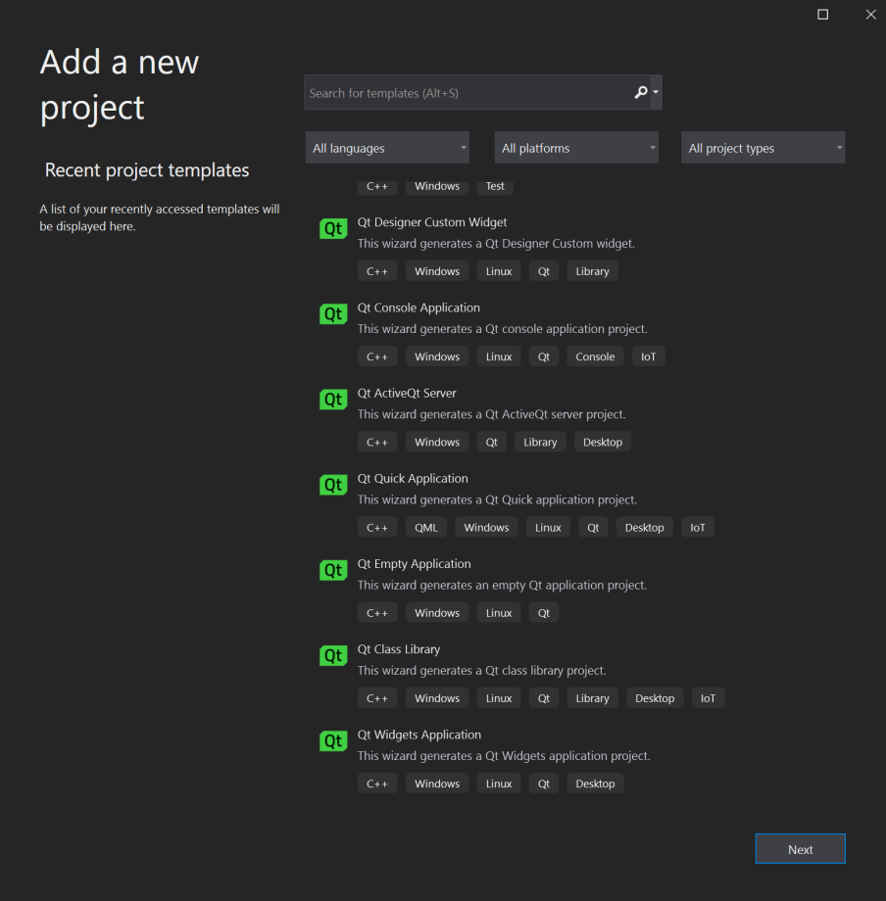

Creating a solution to hold your Qt projects
- On the first screen on VS, select Create a New Project and then the Blank Solution and hit Next:
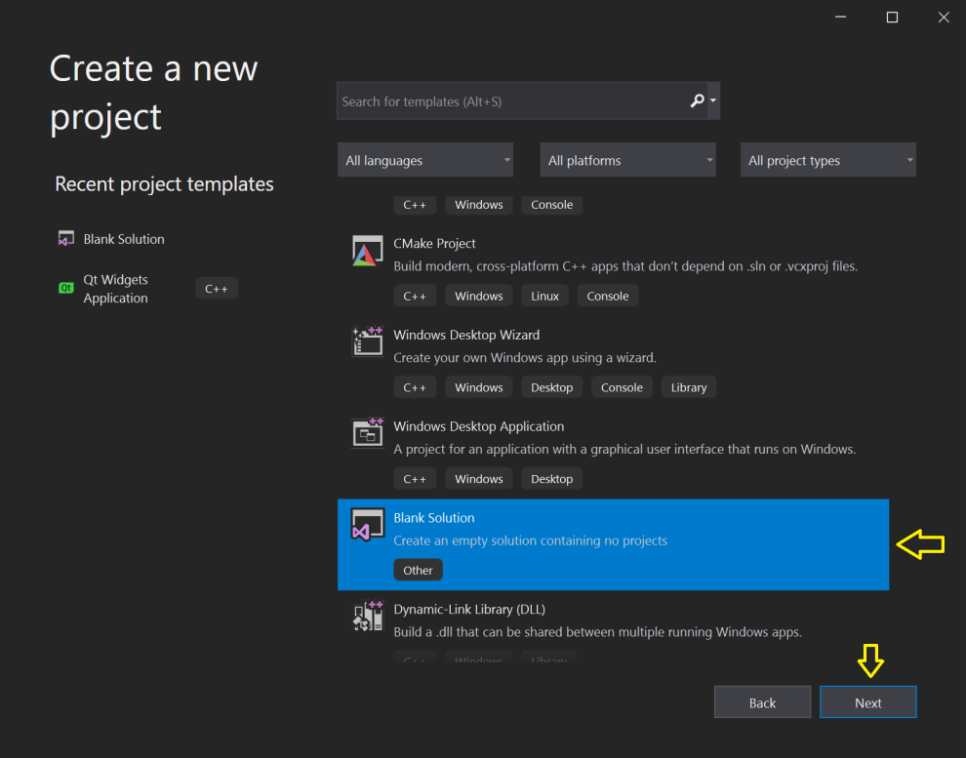
- On the the next screen type the Solution name and hit Create:
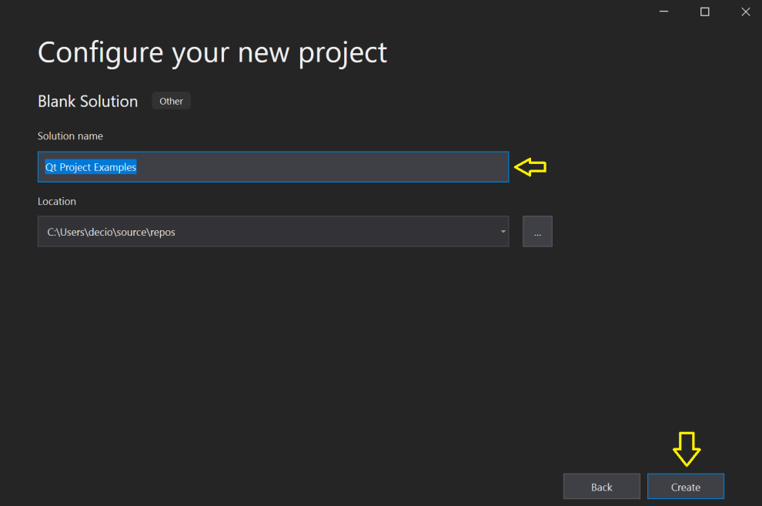
- The next screen will shows the blank solution created by VS to hold your Qt projects.
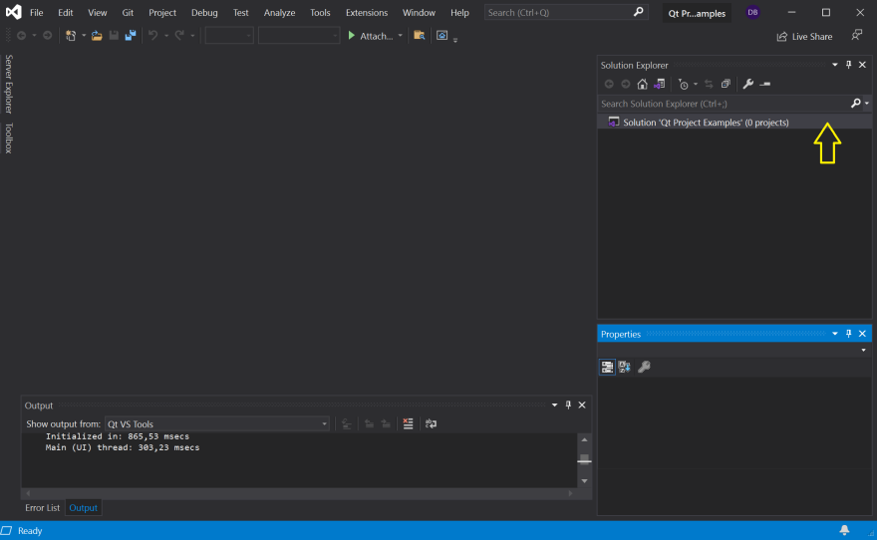

Creating your first project
Applying the horizontal and vertical layouts ensures that the application UI scales to different screen sizes.

- On the screen before, Richt Click over the solution mane on the solution explorer , then select Add and them New Project…
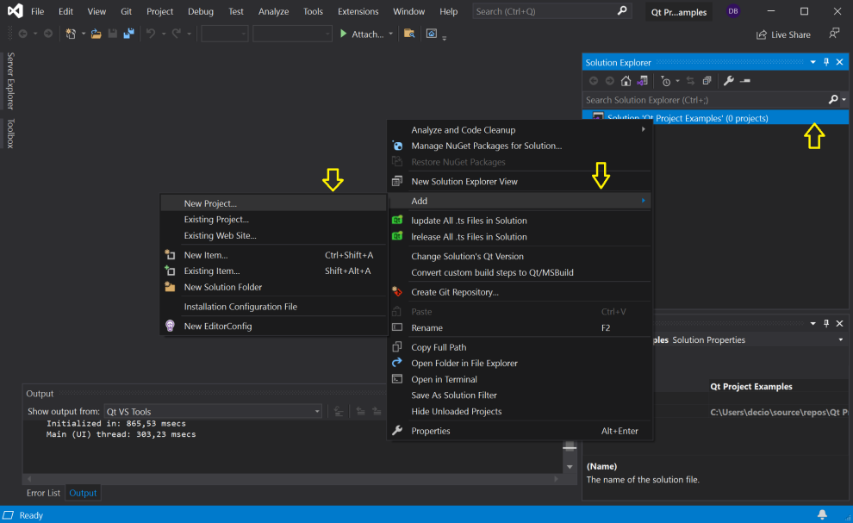
- On the next screen select Qt Widgets Application and them hit Next
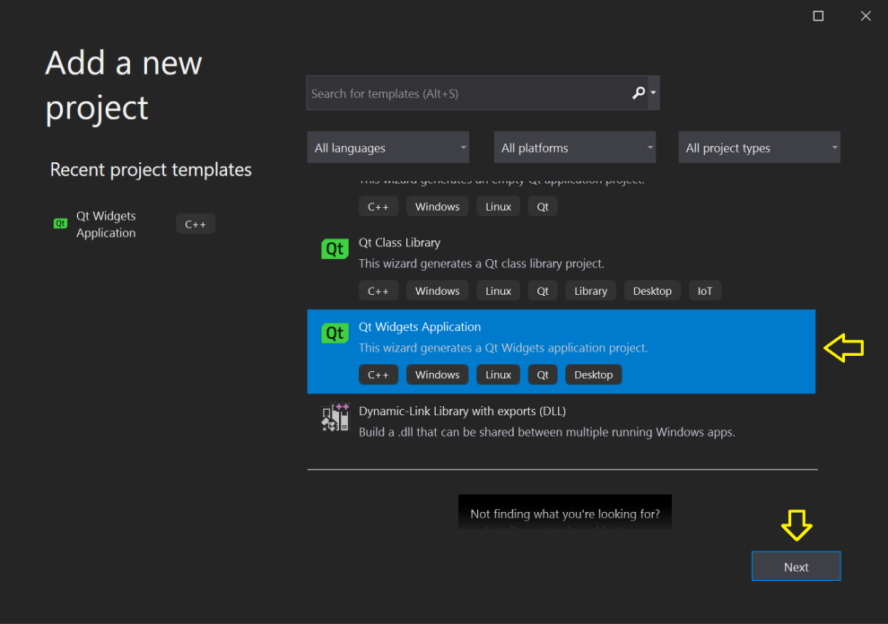
- On the next screen, type the Project Name to create your first project inside the solution created before.
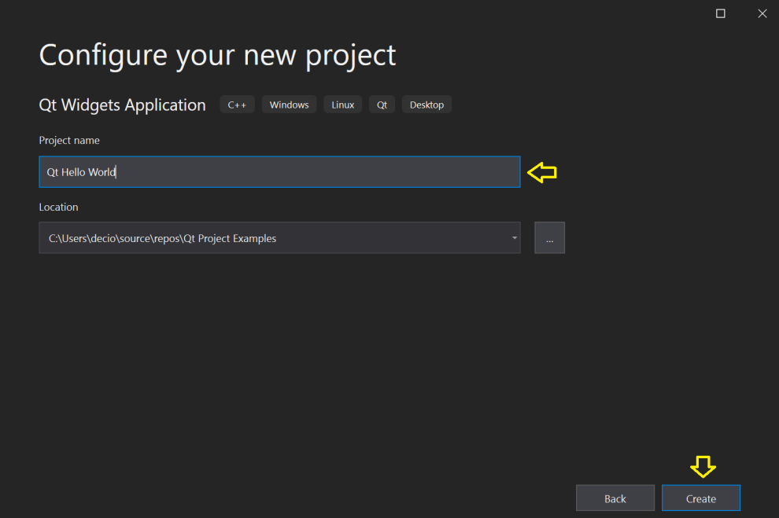

- On the next screen, Qt Visual Studio extension will ask the necessary information to create the Qt project:
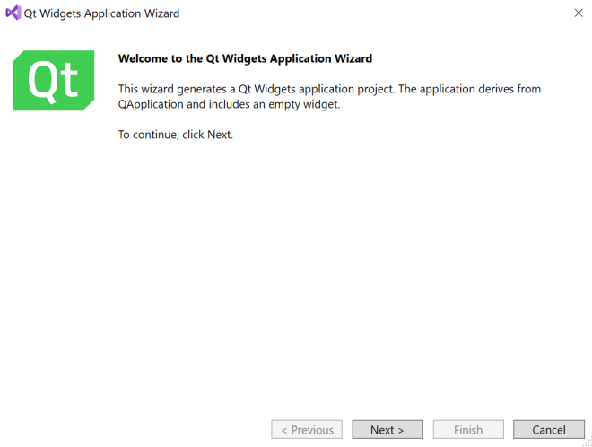 | 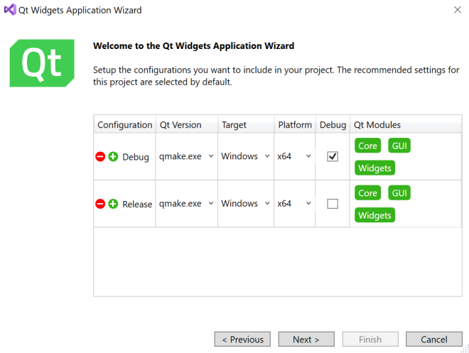
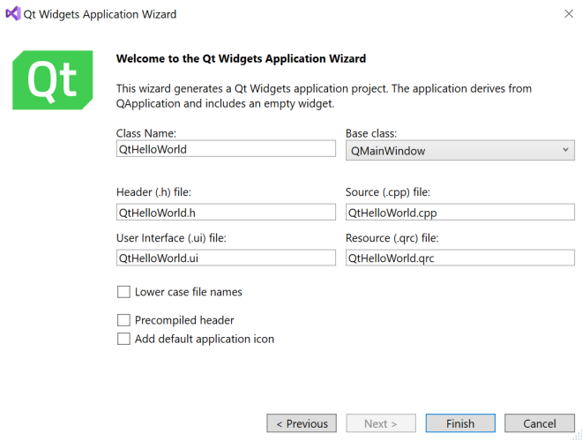

- Hit Finish to create you first Qt project
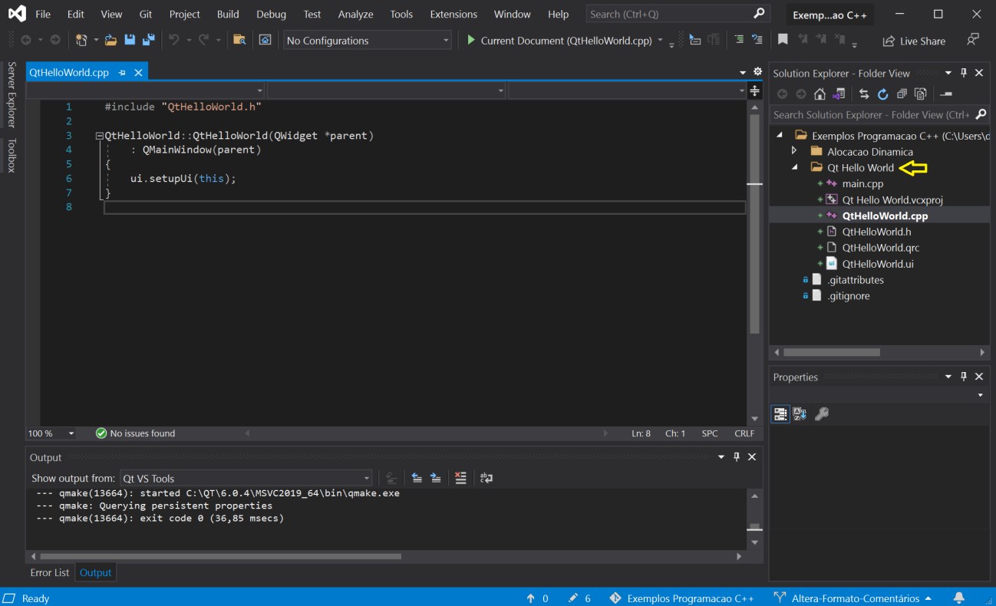
The following files will be created inside the project Qt Hello World:
Main.cpp: this is your main source file. The execution will start here as usual.
QtHelloWorld.ui: this is the main windows of your project. To include your controls (Button, Label, ComboBox, EditLine….) just double click on this file name.
QtHelloWorld.cpp: this is the source code with the implementation of all objects created inside your main window.
QtHelloWorld.h: this is the include file that contains the declaration of all objects used in the main windows.

Configuring your Qt project created
- On the screen before, Richt Click over the Project name on the solution explorer , and then select Properties. On the next screen, select the C++ Language Standard required by Qt: ISO C++ 17 Standard (/std:c++17)
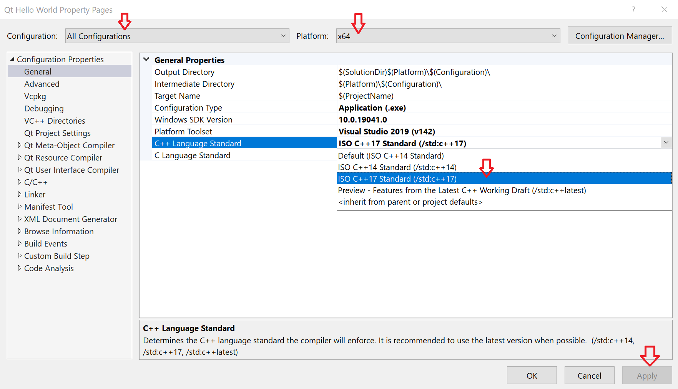
NOTE: Configuration should be: All Configurations.

Including the desired controls on your main window
VS will use the Qt Designer to edit your main windows. To access the Qt designer, double click over the interface file name: QHelloWorld.ui
The Qt designer will be shown on VS as illustrated bellow:
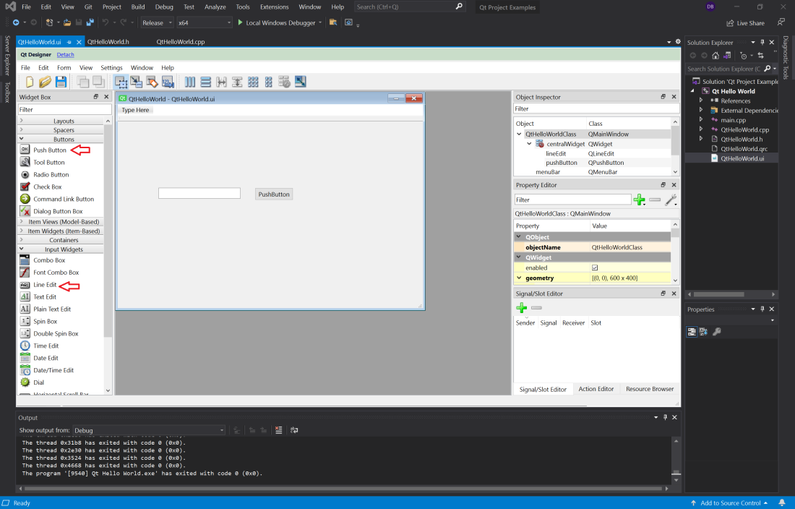
The Qt designer, include two controls: Line Edit and Push Button.

Executing your first Qt program
Execute your program as illustrated bellow:
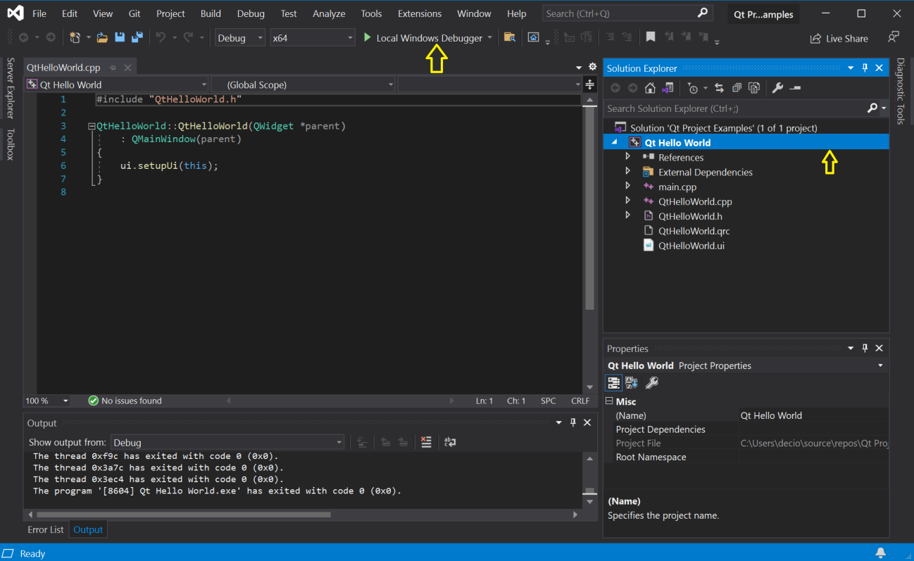

The next screen you show your main window.

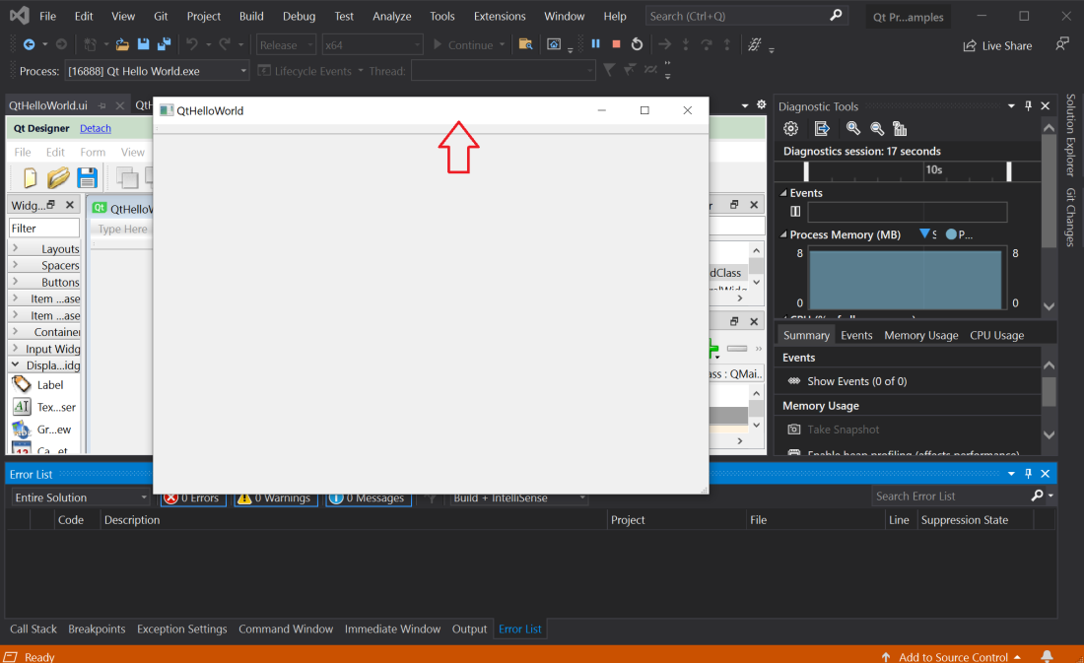

Understanding how it works
As described earlier, the new Qt project created 3 files on VS. Here we will describe better the context and purpose of each of these files.
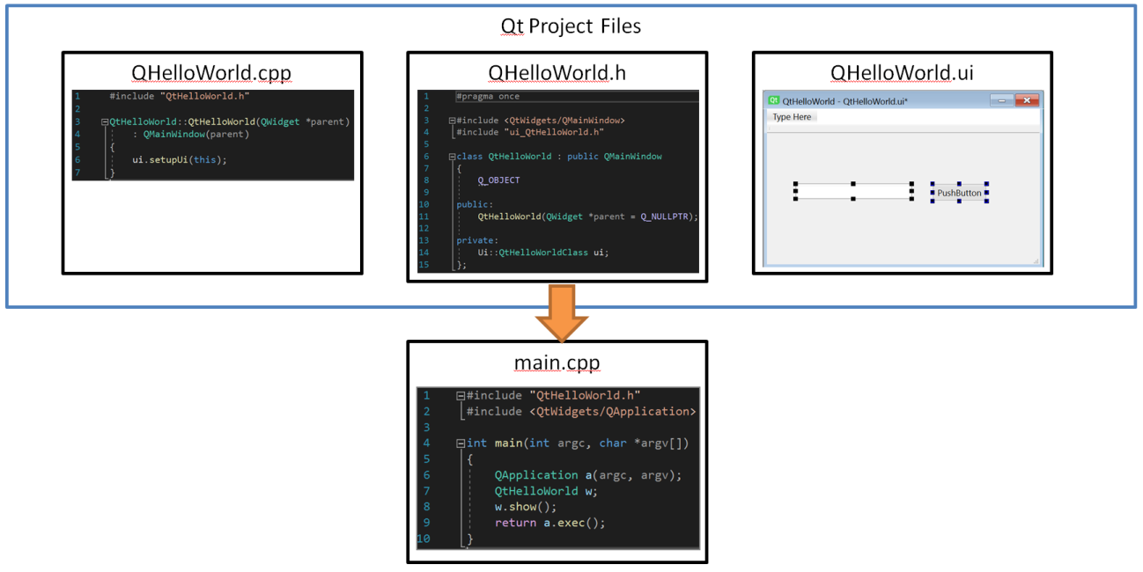

Main.cpp
This is the entry point of your program. Every Qt project has a main.cpp that looks the same as this one. Following we will describe each instruction on the main.cpp file.
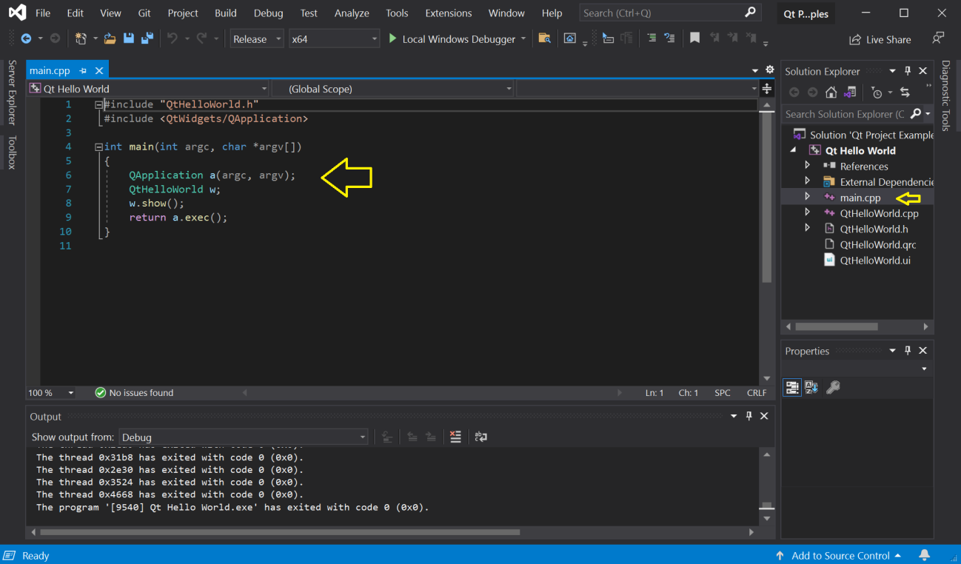

#Includes: The following lines include the header files for the Notepad widget and QApplication. All Qt classes have a header file named after them.
int main(int argc, char *argv[]): The following line defines the main function that is the entry point for all C and C++ based applications.
QApplication a(argc, argv): The following line creates a QApplication object. This object manages application-wide resources and is necessary to run any Qt program that uses Qt Widgets. It constructs an application object with argc command line arguments run in argv. (For GUI applications that do not use Qt Widgets, you can use QGuiApplication instead.).
ClientExample w: The following line creates the “ClientExample” object. This is the object for which the wizard created the class and the UI file. The user interface contains visual elements that are called widgets in Qt. Examples of widgets are text edits, scroll bars, labels, and radio buttons. A widget can also be a container for other widgets; a dialog or a main application window, for example.
w.show(): The following line shows the “ClientExample” widget on the screen in its own window. Widgets can also function as containers. An example of this is QMainWindow which often contains several types of widgets. Widgets are not visible by default; the function show() makes the widget visible.
return a.exec():The following line makes the QApplication enter its event loop. When a Qt application is running, events are generated and sent to the widgets of the application. Examples of events are mouse presses and key strokes.

QHelloWorld.ui
This is the file that holds your main window. The file content is updated using the QtDesigner that is invoked when you double click over the file name on the solution explorer.
Each visual control that you add to your main windows, is include on this file.
Basically this file has class definition with the declaration of each control used by you.
To have access to the C++ code associated with your main windows, access Form -> View C++ Code on the QtDesigner.
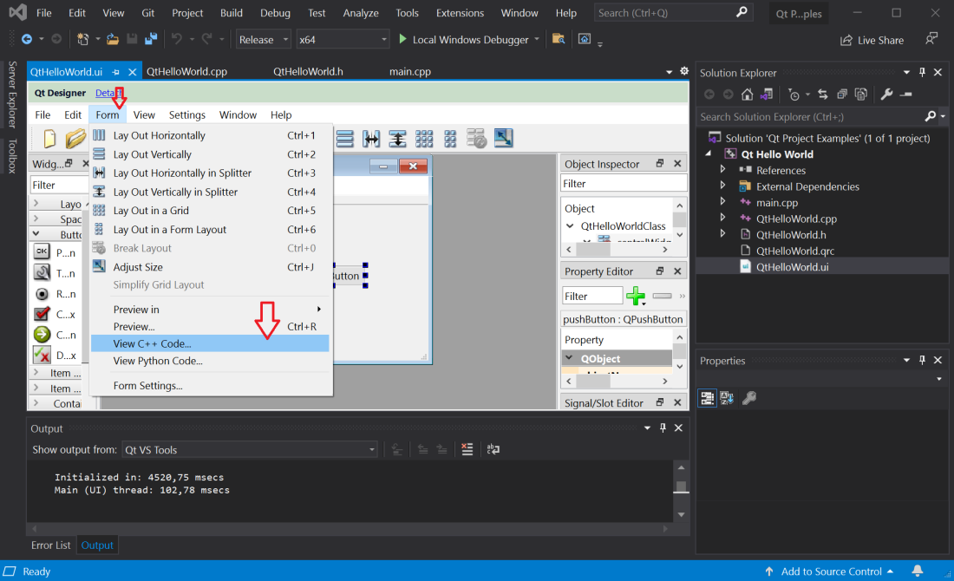
The following code is a portion of the C++ file associated with your main window that we will use to understand it’s main blocks.

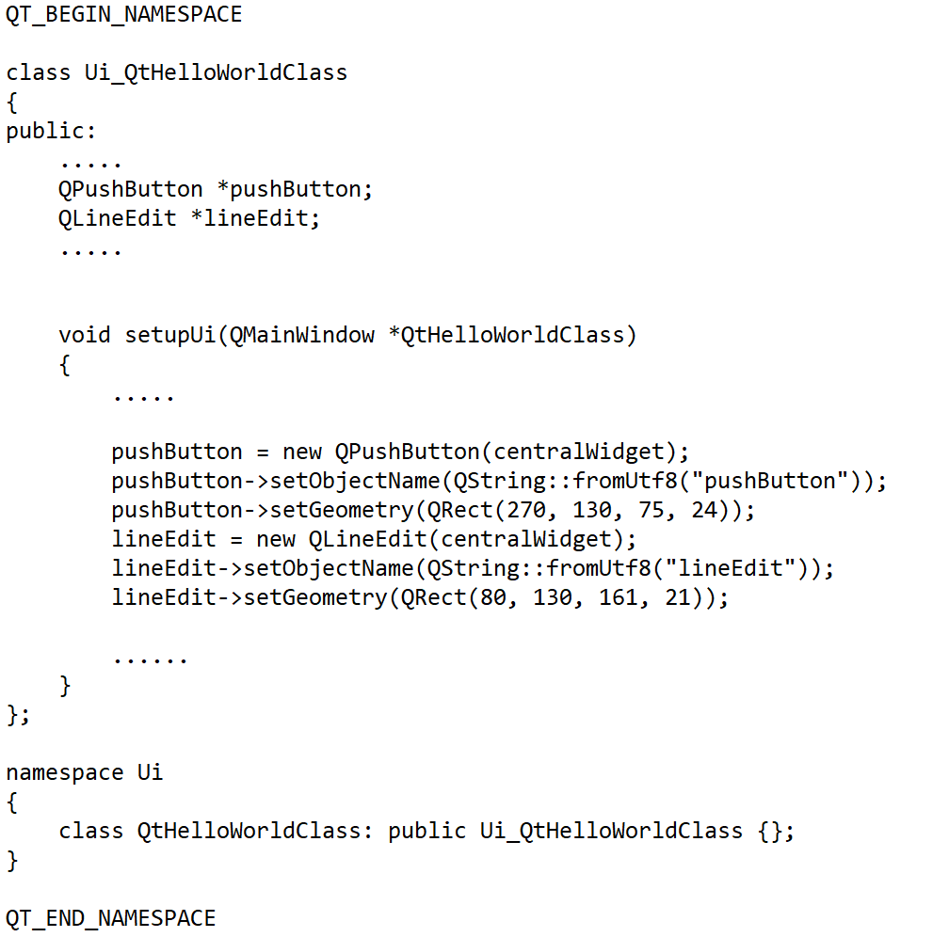

Ui_QtHelloWorldClass: This the class definition of the main windows. It contains a pointer to each visual control added to the interface and a method called setupUI which is responsible for the creation and initial configuration of each control.
Setup_Ui: This method is responsible for the creation of each visual control. It also make the initial configuration of these controls.
namespace Ui: Here it creates a name space definition (Ui) to the class defined before .

QHelloWorld.h
This is your main window include file that holds the class declaration.
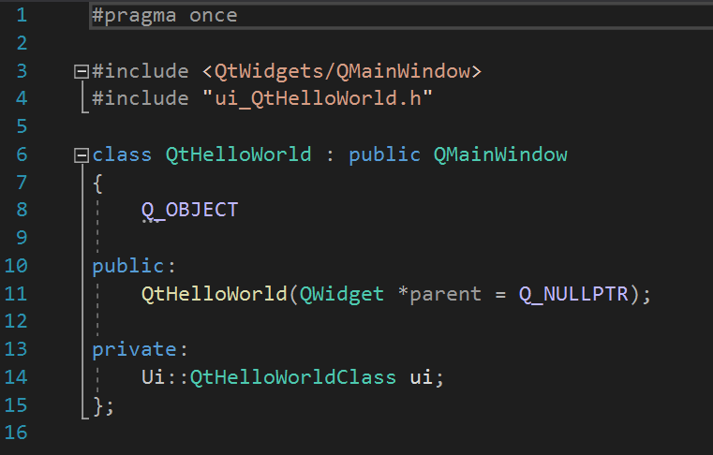
class QtHelloWorld: this is the class definition of your QtHelloWorld main window. It inherit the class QMainWindow. The inheritance definition was specified during the Qtproject creation as described on Step 4 of Creating your first project.
Ui::QtHelloWorldClass ui: this part of the code defines a class (ui) of the type class Ui::QtHeloWorldClass. This is the class that will be used to access all the visual controls include in your windows.

QtHelloWorld(QWidget *parent = Q_NULLPTR): this is the creator method of the class.

QHelloWorld.cpp
This is the c++ code that implements the functionalities associated with your implementation of the QtHelloWorld application. At this point it has only the creator method implemented.
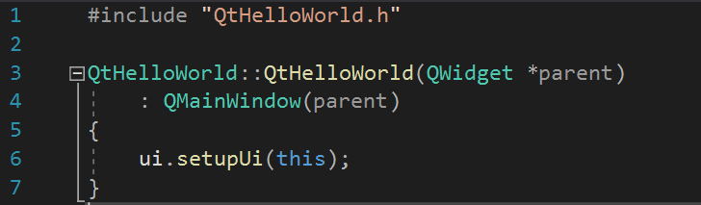
ui.setupUi(this): This part of the code is responsible for the instantiation of all the widgets inside your main windows.

Developing your first functionality on QtHelloWorld
The use case of QtHelloWorld is very simple. When we click the button we want that the phrase “Hello World!” be show on the EditLine box of the window.
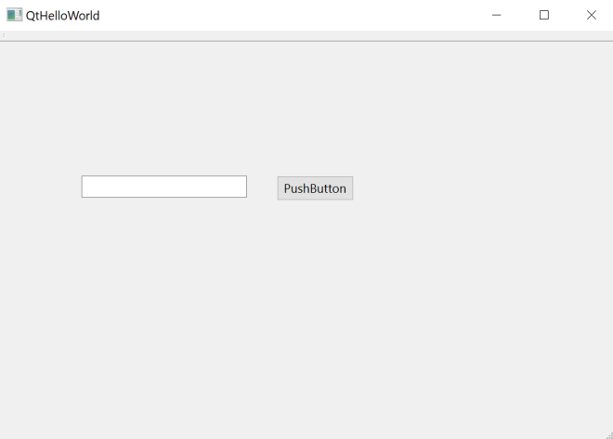
At this point, it is important to understand how a windows program works. Basically hwen you run a windows program it shows a windows (main windows) and holds the program execution waiting for the events that will be generated by your program.
The functionalities you plan to develop will be done trough the implementation of functions to handle the events. In this case, we will create a function to handle the click event of the PushButton.
Using Qt this is accomplish by using the Signal/Slot concept.

The Signal/Slot concept
This is how Qt “links” your signals with the functionality will want to develop. Qt uses the connect function to implement these “links”.
The syntax of the connect is the following:
connect (<sender>, <signal>, <receiver>, <slot>);

<sender>: is the widget that will generate the signal.
<signal>: is the signal, from the sender, that the connect will be lisneting.
<receiver>: this is the object that holds the function(method) that will called when the sender send the signal.
<slot>: this is the function(method), declared inside the receiver, that will be called once the signal is raised by the sender.

The slot function Declaration
The <slot> function that will be “linked” to the signal should always have the same type.
int <function_name>()
{
}

The declaration should be on the public slots: section of out QtHelloWorld class on the file QtHelloWorld.h file as illustrated bellow:

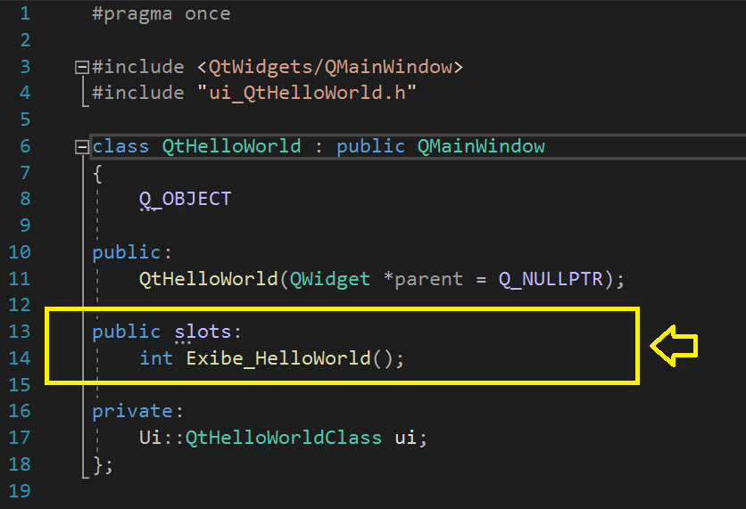

The slot function Implementation
Once out slot function is declared, the next step is to implement it on the QtHelloWorld.cpp file as illustrated bellow:

